High Flux reactor PIK

Basic features
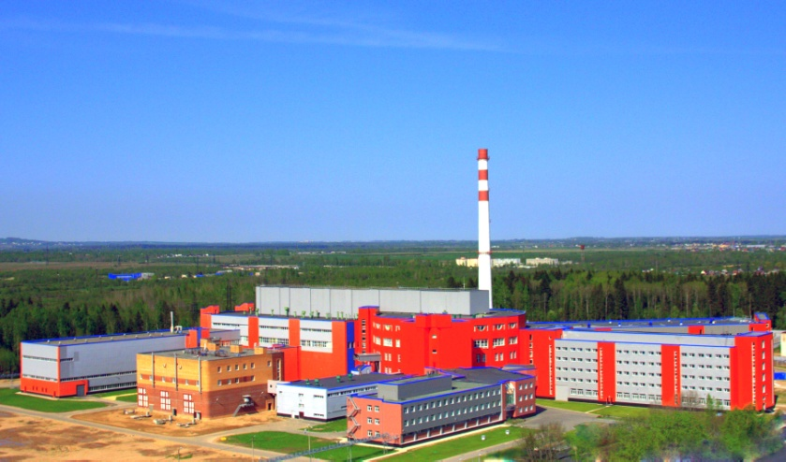
The high flux research reactor PIK is a continuous flow type reactor and is intended for research in the field of condensed matter physics, nuclear physics and the physics of weak interactions, structural and radiation biology and biophysics, radiation physics and chemistry, as well as solutions for many applications and engineering problems. By its parameters PIK reactor will be one of the best research reactors in the world.
The maximum heat output | 100 MW
Thermal neutron flux density (maximum) | 5 ·10¹⁵ cm² · s¹
Thermal neutron flux density in the reflector | 1,3 ·10¹⁵ cm² · s¹
The volumetric energy release in the core  average  maximum | 2,0 MW/l  6,6 MW/l
Heat transfer agent | water
Reflector | heavy water
Number of horizontal experimental channels | 10
Number inclined experimental channels | 6
Number of vertical experimental channels | 6
Number of cold neutron sources | 3
Hot neutron source | 1
Number of experimental stations | 50

PIK reactor differs from the majority of similar projects by increased neutron fluxes in the reflector, the presence of a neutron trap with a very high flux and the possibility of irradiation of materials in the core. The maximum density of the unperturbed thermal neutron flux is close to 5 ·10¹⁵ cm² · s¹ and corresponds to the record values ​​obtained in a continuous flow reactors.

